CROSS BORDER CARBON CAPTURE AND STORAGE: EMISSION MITIGATION POTENTIAL AND MRV SYSTEM FOR REGIONAL DECARBONIZATION PATHWAY

JOHN TING ZHI ZHANG

UNIVERSITI TEKNOLOGI MALAYSIA
PSZ 19:16 (Pind. 1/23)


UNIVERSITI TEKNOLOGI MALAYSIA
DECLARATION OF Choose an item.

Author’s full name | :
Student’s Matric No. | : |  | Academic Session | :
Date of Birth | : |  | UTM Email | :
Choose an item. Title | : | TITLE IN CAPITAL LETTERS  TITLE IN CAPITAL LETTERS  TITLE IN CAPITAL LETTERS
I declare that this thesis is classified as:
☒ | OPEN ACCESS | I agree that my report to be published as a hard copy or made available through online open access.
 | RESTRICTED | Contains restricted information as specified by the organization/institution where research was done.  (The library will block access for up to three (3) years)
☐ | RESTRICTED
☐ | CONFIDENTIAL | Contains confidential information as specified in the Official Secret Act 1972)
(If none of the options are selected, the first option will be chosen by default)

I acknowledged the intellectual property in the Choose an item. belongs to Universiti Teknologi Malaysia, and I agree to allow this to be placed in the library under the following terms :
- This is the property of Universiti Teknologi Malaysia
- The Library of Universiti Teknologi Malaysia has the right to make copies for the purpose of research only.
- The Library of Universiti Teknologi Malaysia is allowed to make copies of this Choose an item. for academic exchange.
Signature of Student:
Signature :

Full Name
Date :
Approved by Supervisor(s)

Signature of Supervisor I: | Signature of Supervisor II
Full Name of Supervisor I  NOOR HAZARINA HASHIM | Full Name of Supervisor II  MOHD ZULI JAAFAR
Date : | Date :

NOTES : If the thesis is CONFIDENTIAL or RESTRICTED, please attach with the letter from the organization with period and reasons for confidentiality or restriction

Note: This page is only applicable for theses classified as Restricted/Confidential. Please delete this page from the template if your thesis is not classified as Restricted/Confidential. This letter should be written by a supervisor and addressed to Perpustakaan UTM. A copy of this letter should be attached to the thesis.
Date:
Librarian
Jabatan Perpustakaan UTM,
Universiti Teknologi Malaysia,
Johor Bahru, Johor

Sir,

CLASSIFICATION OF THESIS AS RESTRICTED/CONFIDENTIAL
TITLE: Click or tap here to enter text.
AUTHOR'S FULL NAME:Click or tap here to enter text.

Please be informed that the above-mentioned thesis titled _________ should be classified as RESTRICTED/CONFIDENTIAL for a period of three (3) years from the date of this letter. The reasons for this classification are
(i)
(ii)
(iii)

Thank you.

Yours sincerely,

SIGNATURE:
NAME:
ADDRESS OF SUPERVISOR:

“Choose an item. hereby declare that Choose an item. have read this Choose an item. and in Choose an item.
opinion this Choose an item. is sufficient in term of scope and quality for the
award of the degree of Choose an item.”

Signature | : | ________________________________
Name of Supervisor I | : | KHAIRUR RIJAL JAMALUDIN
Date | : | 9 May 2017
Signature | : | ________________________________
Name of Supervisor II | : | NOOR HAZARINA HASHIM
Date | : | 9 May 2017
Signature | : | ________________________________
Name of Supervisor III | : | MOHD ZULI JAAFAR
Date | : | 9 May 2017

Declaration of Cooperation

This is to confirm that this research has been conducted through a collaboration Click or tap here to enter text. and Click or tap here to enter text.

Certified by:

Signature | :
Name | :
Position | :
Official Stamp
Date

* This section is to be filled up for theses with industrial collaboration

Pengesahan Peperiksaan

Tesis ini telah diperiksa dan diakui oleh:

Nama dan Alamat Pemeriksa Luar | :
Nama dan Alamat Pemeriksa Dalam | :
Nama Penyelia Lain (jika ada) | :

Disahkan oleh Timbalan Pendaftar di Fakulti:
Tandatangan | :
Nama | :
Tarikh | :

ON-LINE RECOGNITION OF DEVELOPING CONTROL CHART PATTERNS
TITLE
TITLE
TITLE

WAN ZUKI AZMAN WAN MUHAMAD

A Choose an item. submitted in Choose an item. of the
requirements for the award of the degree of
Choose an item.

School of Education
Faculty of Social Sciences and Humanities
Universiti Teknologi Malaysia

OCTOBER 2024

DECLARATION

I declare that this Choose an item. entitled “title of the thesis” is the result of my own research except as cited in the references. The Choose an item. has not been accepted for any degree and is not concurrently submitted in candidature of any other degree.
Signature | : | ....................................................
Name | :
Date | : | 10 November 2016

ACKNOWLEDGEMENT
In preparing this thesis, I was in contact with many people, researchers, academicians, and practitioners. They have contributed towards my understanding and thoughts. In particular, I wish to express my sincere appreciation to my main thesis supervisor, Professor Dr. Mohd Shariff Nabi Baksh, for encouragement, guidance, critics and friendship. I am also very thankful to my co-supervisor Professor Dr Awaluddin Mohd Shaharoun and Associate Professor Dr. Hishamuddin Jamaluddin for their guidance, advices and motivation. Without their continued support and interest, this thesis would not have been the same as presented here.
I am also indebted to Universiti Teknologi Malaysia (UTM) for funding my Ph.D study. Librarians at UTM, Cardiff University of Wales and the National University of Singapore also deserve special thanks for their assistance in supplying the relevant literatures.
My fellow postgraduate student should also be recognised for their support. My sincere appreciation also extends to all my colleagues and others who have provided assistance at various occasions. Their views and tips are useful indeed. Unfortunately, it is not possible to list all of them in this limited space. I am grateful to all my family member.

ABSTRACT
The purpose of this study is to investigate the application of genetic algorithm (GA) in modelling linear and non-linear dynamic systems and develop an alternative model structure selection algorithm based on GA. Orthogonal least square (OLS), a gradient descent method was used as the benchmark for the proposed algorithm. A model structure selection based on modified genetic algorithm (MGA) has been proposed in this study to reduce problems of premature convergence in simple GA (SGA). The effect of different combinations of MGA operators on the performance of the developed model was studied and the effectiveness and shortcomings of MGA were highlighted. Results were compared between SGA, MGA and benchmark OLS method. It was discovered that with similar number of dynamic terms, in most cases, MGA performs better than SGA in terms of exploring potential solution and outperformed the OLS algorithm in terms of selected number of terms and predictive accuracy. In addition, the use of local search with MGA for fine-tuning the algorithm was also proposed and investigated, named as memetic algorithm (MA). Simulation results demonstrated that in most cases, MA is able to produce an adequate and parsimonious model that can satisfy the model validation tests with significant advantages over OLS, SGA and MGA methods. Furthermore, the case studies on identification of multivariable systems based on real experiment t al data from two systems namely a turbo alternator and a continuous stirred tank reactor showed that the proposed algorithm could be used as an alternative to adequately identify adequate and parsimonious models for those systems. Abstract must be bilingual. For a thesis written in Bahasa Melayu, the abstract must first be written in Bahasa Melayu and followed by the English translation. If the thesis is written in English, the abstract must be written in English and followed by the translation in Bahasa Melayu. The abstract should be brief, written in one paragraph and not exceed one (1) page. An abstract is different from synopsis or summary of a thesis. It should states the field of study, problem definition, methodology adopted, research process, results obtained and conclusion of the research.
(Note: Students are allowed to use either single or one-and-a-half spacing for the abstract, as long as it fits within one page. The chosen spacing style must be consistent across both the English and Malay sections.)

ABSTRAK
Kajian ini dilakukan bertujuan mengkaji penggunaan algoritma genetik (GA)
dalam pemodelan sistem dinamik linear dan tak linear dan membangunkan kaedah alternatif bagi pcmilihan struktur model menggunakan GA. Algorithma kuasa dua terkecil ortogon (OLS), satu kaedah penurunan kecerunan digunakan sebagai bandingan bagi kaedah yang dicadangkan. Pcmilihan struktur model mengunakan kaedah algoritma genetik yang diubahsuai (MGA) dicadangkan dalam kajian ini bagi
mengurangkan masalah konvergens pramatang dalam algoritma genetik mudah (SGA). Kesan penggunaan gabungan operator MGA yang berbeza ke atas prestasi model yang terbentuk dikaji dan keberkesanan serta kekurangan MGA diu t arakan. Kajian simulasi dilakukan untuk membanding SGA, MGA dan OLS. Dengan meggunakan bilangan parametcr dinamik yang setara kajian ini mendapati, dalam kebanyakan kes, prestasi MGA adalah lebih baik daripada SGA dalam mencari penyelesaian yang berpotensi dan lebih berkebolehan daripada OLS dalam menentukan bilangan sebutan yang dipilih dan ketcpatan ramalan. Di samping itu, penggunaan carian tcmpatan dalam MGA untuk menambah baik algorithma tersebut dicadang dan dikaji, dinamai sebagai algoritma mcmetic (MA). Hasil simulasi menunjukkan, dalam kebanyakan kes, MA berkeupayaan menghasilkan model yang bersesuaian dan parsimoni dan mcmenuhi ujian pengsahihan model di samping mcmperolehi beberapa kelebihan dibandingkan dengan kaedah OLS, SGA dan MGA. Tambahan pula, kajian kes untuk sistcm berbilang pcmbolehubah menggunakan data eksperimental sebenar daripada dua sistem iaitu sistem pengulang-alik turbo dan reaktor teraduk berterusan menunjukkan algoritma ini boleh digunakan sebagai alternatif untuk mcmperolehi model termudah yang memadai bagi sistcm tersebut.
(Note: Students are allowed to use either single or one-and-a-half spacing for the abstract, as long as it fits within one page. The chosen spacing style must be consistent across both the English and Malay sections.)

TABLE OF CONTENTS
 | TITLE | PAGE

DECLARATION iii
ACKNOWLEDGEMENT v
ABSTRACT vi
ABSTRAK vii
TABLE OF CONTENTS viii
LIST OF TABLES x
LIST OF FIGURES xi
LIST OF ABBREVIATIONS xii
LIST OF SYMBOLS xiii
LIST OF APPENDICES xiv
CHAPTER 1 INTRODUCTION 1
1.1 Problem Background 1
1.2 Problem Background 1
1.3 Problem Statement 2
1.4 Research Goal 2
1.4.1 Research Objectives 2
1.5 Captions 3
1.6 Quotation 4
1.7 Equation 4
CHAPTER 2 LITERATURE REVIEW 7
2.1 Introduction 7
2.1.1 State-of-the-Arts 8
2.2 Limitation 8
2.3 Research Gap 8
CHAPTER 3 RESEARCH METHODOLOGY 11
3.1 Introduction 11
3.1.1 Proposed Method 11
3.1.1.1 Research Activities 11
3.2 Tools and Platforms 12
3.3 Chapter Summary 12
CHAPTER 4 PROPOSED WORK 13
4.1 The Big Picture 13
4.2 Analytical Proofs 13
4.3 Result and Discussion 14
4.4 Chapter Summary 14
CHAPTER 5 CONCLUSION AND RECOMMENDATIONS 17
5.1 Research Outcomes 17
5.2 Contributions to Knowledge 17
5.3 Future Works 17
REFERENCES 19
LIST OF PUBLICATIONS 24

LIST OF TABLES
TABLE NO. | TITLE | PAGE
Table ‎1.1 The role of statistical quality engineering tools and methodologies 4
Table ‎1.2 Basic ANN models used for control chart pattern recognition 4
Table ‎2.1 Regression analysis for the results of preliminary feature screening 7
Table ‎2.2 Estimated effects and regression coefficients for the recogniser's performance (reduced model) 7
Table ‎5.1 Example Repeated Header Table 17

LIST OF FIGURES
FIGURE NO. | TITLE | PAGE
Figure ‎1.1 Trends leading to the problem using MZJ Formatting Method 3
Figure ‎1.2 Design and development phases of the proposed scheme (Muhamad, 2018) 3
Figure ‎2.1 Continuous variability reduction using SPC chart (Revelle and Harrington, 1992) 7
Figure ‎2.2 Typical fully developed patterns on Shewhart control chart (Cheng, 1989) 7
Figure ‎3.1 Example of Formatting Method 12
Figure ‎4.1 This is MZJ original idea 13
Figure ‎4.2 The method for hig performance formatting 14

LIST OF ABBREVIATIONS
ANN | - | Artificial Neural Network
GA | - | Genetic Algorithm
PSO | - | Particle Swarm Optimization
MTS | - | Mahalanobis Taguchi System
MD | - | Mahalanobis Distance
TM | - | Taguchi Method
UTM | - | Universiti Teknologi Malaysia
XML | - | Extensible Markup Language
ANN | - | Artificial Neural Network
GA | - | Genetic Algorithm
PSO | - | Particle Swarm Optimization

LIST OF SYMBOLS
δ | - | Minimal error
 | - | Diameter
 | - | Force
 | - | Velocity
 | - | Pressure
 | - | Moment of Inersia
 | - | Radius
 | - | Reynold Number

LIST OF APPENDICES
APPENDIX | TITLE | PAGE
Appendix A Mathematical Proofs 21
Appendix B Psuedo Code 22
Appendix C Time-series Results Long Long Long Long Long Long Long Long Long Long 23

INTRODUCTION

Research Background
PETRONAS, MISC and MOL formed a joint venture in June 2025 to develop liquefied CO₂ carriers for cross‑border CCS. This demonstrates Malaysia’s commitment to providing storage services for neighboring countries. Including these developments in your introduction or case‑study section will root the thesis in current industry practice
In carbon custody chains involving producers, pipelines, hub tanks, maritime transport, intermediate terminals, and final storage sites, the deployment of custody meters has become standard practice. These instruments provide accurate readings of CO₂ flow rates and inventories at key physical points. However, despite the precision of these measurements, instrumentation alone is insufficient to construct a complete, auditable custody system. To achieve a coherent and accountable framework, mass-balance equations are essential. These equations play a foundational role in integrating isolated flow data into a network-wide reconciliation that ensures system integrity and regulatory compliance.
First, mass-balance equations enable closure across the entire chain by connecting flow and inventory measurements through a simple but powerful accounting identity: CO₂ Produced = CO₂ Stored + Losses + Inventory Change. This reconciliation is critical for demonstrating that every tonne of CO₂ captured is properly accounted for, especially under regulated carbon market conditions or compliance regimes. Without this closure, there is no assurance that the system is leak-tight in an accounting sense, even if physical losses are minimal.
Second, mass-balance equations facilitate the allocation of responsibility for losses that naturally occur in the system—such as boil-off from ships, venting from tanks, and shrinkage in pipelines. While instruments may detect discrepancies, only the mass-balance framework can localize and assign these losses to specific segments of the chain. This capability ensures that accountability is preserved: pipeline losses are attributed to producer-hub links, ship losses to the transport operator, and terminal losses to the storage or handling facility.
Third, traceability—critical in carbon credit markets—is achieved through batch-indexed mass-balance equations. These allow for the provenance of captured CO₂ to be maintained as it moves through each node in the custody chain. Such batch-level tracking is essential for the issuance of verifiable credits, giving regulators, auditors, and buyers confidence in the origin and integrity of stored carbon.
Moreover, mass-balance equations enhance the auditability of the system. Regulatory authorities and third-party verifiers require more than raw instrument data; they expect an organized, transparent framework of inflows, outflows, losses, and inventories. A mass-balance model satisfies this need by providing a reconcilable, structured record that supports formal audits and compliance verification.
Finally, beyond regulatory compliance, mass balances serve as a valuable operational tool. They enable operators to identify abnormal loss rates, detect instrument malfunctions, and optimize infrastructure planning. Every tonne of CO₂ that goes unaccounted for represents not only a potential emissions liability but also a forfeited carbon credit. The application of mass-balance principles helps surface these inefficiencies, making them visible and actionable for both operators and regulators.

Problem Statement
Cross-border carbon capture and storage (CCS) chains—where carbon dioxide (CO₂) is captured in one country and permanently stored in another—introduce complex governance and technical challenges to existing Monitoring, Reporting and Verification (MRV) systems. Current MRV frameworks often exhibit fragmented practices, non-uniform application of standards, and limited cross-jurisdictional trust among participating countries and project developers. These issues collectively undermine the accuracy, transparency, and credibility of transboundary emissions accounting.
Firstly, custody measurement inconsistencies remain a critical concern across the CCS value chain. Variations occur at multiple transfer points—during capture, export, transport, import, and storage—resulting in discrepancies between recorded CO₂ volumes and compositions. Without harmonized measurement protocols, these inconsistencies compromise the integrity of carbon accounting across jurisdictions.
Secondly, uncertainty propagation in measurement systems arises from multiple technical factors, including meter calibration errors, changes in gas composition, variations in equations of state (EOS), and data gaps in telemetry systems. Moreover, there is a lack of transparent and standardized rules for reconciling or harmonizing these measurement differences. In simple terms, this reflects the absence of clear procedures on how to handle or correct inconsistencies or missing data across project stages.
Thirdly, cross-country governance mechanisms pose regulatory challenges, particularly concerning authorization and carbon accounting under Article 6.2 of the Paris Agreement. This Article allows countries to transfer carbon credits—referred to as Internationally Transferred Mitigation Outcomes (ITMOs)—between one another. To operationalize this mechanism, both the capturing and storing countries must formally authorize the transfer of emission reductions and clearly identify which party will claim the corresponding mitigation outcome towards its Nationally Determined Contribution (NDC). Avoiding double counting is essential: if CO₂ is captured in Country A and transported for storage in Country B, only one of the two countries may record the associated emission reduction in its national inventory.
Lastly, real-time auditability and dispute resolution remain underdeveloped in cross-border CCS governance. Real-time auditability refers to the capacity for all stakeholders—operators, regulators, and verification bodies—to access and verify CO₂ monitoring data simultaneously as it is collected. Given that different actors may hold asymmetric incentives—for instance, project developers aiming to maximize creditable CO₂ volumes versus regulators prioritizing data integrity—a transparent and fair dispute resolution mechanism is necessary. Such a system would enable disagreements over data accuracy or credit ownership to be resolved efficiently and equitably.
In summary, the establishment of a robust cross-border MRV framework requires not only technical standardization and data harmonization but also institutional mechanisms to ensure trust, transparency, and accountability between participating jurisdictions.

Research Objectives

LITERATURE REVIEW

Introduction
This literature review will explore more on the GHG emission with cross border MRV system concept.
- MRV Concept
- ISO/TR 27915
ISO/TR 27915 is a technical report created by ISO Technical Committee 265 (TC 265) as a foundation for future standards on the quantification and verification (Q&V) of greenhouse gas (GHG) emissions and removals associated with carbon capture and storage (CCS) projects. The report explains that robust accounting is needed to meet the climate goals under the Paris Agreement. Many climate models indicate that keeping global temperature rise below 2 °C requires widespread deployment of CCS technologies and possibly bio‑energy with CCS (BECCS) and direct air CO₂ capture and storage (DACCS). The document integrates practices from six ISO/TC 265 working groups (Capture, Transport, Storage, Quantification and Verification, Cross‑cutting issues and CO₂ storage through enhanced oil recovery) and is meant to guide regulators, project developers, investors and other stakeholders.
There are several terminologies that are important before diving into quantification and verifications.
Term | Definition
Baseline | A reference state against which project performance is monitored.
Carbon Capture and Storage (CCS) | The process of separating CO₂ from industrial or energy sources, transporting it, and injecting it into geological formations for long-term isolation.
CO₂ Leakage | Unintended release of CO₂ or other greenhouse gases (GHGs) from containment systems such as compressors, pipelines, wells, or geological formations.
CO₂ Stream Composition and Purity | The chemical composition of a captured CO₂ stream; impurities (e.g., other gases or substances) may need to be measured and controlled to ensure storage integrity.
GHG Emission | The total mass of greenhouse gases released into the atmosphere or surface waters over a specified period.
GHG Removal | The total mass of greenhouse gases removed from the atmosphere, such as through Bioenergy with Carbon Capture and Storage (BECCS) or Direct Air Carbon Capture and Storage (DACCS).
GHG Activity Data | Quantitative data describing activities that result in GHG emissions or removals (e.g., fuel use, production rates).
Emission Factors | Coefficients that quantify emissions per unit of activity data, used to estimate GHG emissions.
Fugitive Emissions | Unintentional releases of GHGs from equipment leaks, venting, or other non-combustion processes.
Integrated CCS Project | A project that includes all components of the CCS chain — capture, transport, and storage — under a unified management and MRV framework.
Sampling | The process of collecting representative samples (e.g., gas, fluid, or rock) for measurement and analysis within an MRV system.
Monitoring and Verification | Systematic observation, measurement, and confirmation that CCS project performance aligns with expected results and regulatory requirements.

In term of system boundary, CCS system consists of the capture installation, treatment facilities, transport equipment (pipelines or ships), reception facilities, injection facility and subsurface geological components. The boundary extends vertically and laterally to cover the storage complex where the CO₂ plume stabilizes. Operators may justify different boundaries when technical or regulatory conditions differ (e.g., pipelines serving multiple sources, partial integration of CCS at a multi‑boiler plant). In term of GHG emission quantification approaches, Inventory account – Creates emissions inventories (e.g., national inventories). CCS projects quantify emissions in absolute terms and determine CO₂ stored using mass‑balance equations. Cap‑and‑trade account – Participants report emissions, surrender allowances equal to emissions and may trade allowances. In the EU ETS, capture, transport and storage are separate installations and each must quantify and report emissions. Baseline‑emission reduction account – Calculates reductions relative to a baseline scenario, used by the Clean Development Mechanism and ISO 14064‑2. Life Cycle Assessment (LCA) – Evaluates environmental impacts across the entire life cycle; details are in Clause 8. The scope of GHG emissions can be categorized as direct which includes stationary and mobile combustion, fugitive emissions (leaks, spills, vents) and process emissions while for indirect which includes energy consumption, upstream/downstream activities and market effects. Type of emission sources includes Capture system: additional fuel used for gas treatment and compression; incomplete capture of CO₂; fugitive emissions from leaks, vents and flares. Transportation system: energy for transport (compression, pumping or shipping); leaks from pressurized/cryogenic equipment; emissions during loading/unloading; venting during emergencies. Both pipeline and non‑pipeline transport must account for emissions from fuel use and any venting of liquefied CO₂. Storage system: energy for pumping/compressing CO₂; potential leaks from geological formations or wells; emissions from production wells; fugitive emissions from surface equipment. Other emissions: construction and decommissioning of facilities, upstream/downstream processes for materials and energy, and additional activities attributable to CCS. Some of the GHG accounting programs Seven existing programs are compared (IPCC national inventories, CDM, EU ETS, Alberta protocols, US EPA GHG Reporting, and LCA). The comparison table summarises aggregation level (national, project or installation), purpose (emissions or emission reduction), reporting period, project boundaries, GHG types and emission sources. Key insights include: National inventories and the CDM include all Kyoto GHGs, whereas EU ETS and Alberta protocols focus mainly on CO₂. The EU ETS treats capture, transport and storage as separate installations and requires annual reporting and verification. LCA is project-dependent and includes all GHGs and environmental impacts; it can use various functional units (e.g., kWh, tonnes of product, tonnes of CO₂ avoided).
Measurement aspect also vital in the MRV system which Figure 6 (described in the report) illustrates key measurement points across CCS projects—capture inlet/outlet, transport entry/exit and storage injection/production—to quantify CO₂ streams and detect leaks. Table 6 lists required measurements: for CO₂ emission reductions (temperature, pressure, flow rates, CO₂ concentrations), leak detection (monitoring pipeline and wellbore leaks), and indirect energy consumption. CCS starts with capture system potential emission sources include energy used for separation and treatment, incomplete capture, and fugitive releases. Sensors can measure CO₂ concentration, flow rate, pressure and temperature; IPCC Tier 1 and 2 emission-factor approaches may suffice. For transportation system, Emissions arise from energy used for transport, equipment leakage, loading/offloading and emergency venting. Critical measurement points are the inlet and outlet of the transport system. Indirect emissions from compressor stations must be calculated using fuel data and regional electricity mix. Non-pipeline transport may involve venting due to warming of liquefied CO₂. In term of storage system, Tier 3 methods (site‑specific measurement and modelling) are required due to limited emission‑factor data and site‑specific conditions. Mass‑balance approaches quantify stored CO₂ by subtracting leakage from injected amounts. Monitoring includes geophysical/geochemical surveillance to confirm plume containment and detect leaks through faults, fractures or wells. Operators should develop monitoring plans specifying measurement types, frequency, precision and data archiving; energy used during monitoring must also be accounted for. Impurities in the CO₂ stream (N₂, O₂, H₂, Ar, CH₄, CO and trace compounds) can affect capture equipment and storage behaviour; monitoring plans should consider risks related to impurities. LCA evaluates full environmental impacts (not just GHG) and uses spatial boundaries covering inputs and outputs across capture, transport and storage. It defines temporal boundaries (construction, operation, closure, post‑closure) and requires careful choice of functional unit. Environmental impact categories (abiotic depletion, acidification, eutrophication, toxicity) must be selected based on project objectives.
Lastly will be data management, reporting and validation. Programs require procedures for data management to ensure accuracy, completeness and transparency. ISO 14064‑1 mandates information management systems with routine checks, error identification and documentation. The EU ETS Monitoring and Reporting Regulation (MRR) requires operators to implement control systems comprising risk assessments and control activities (equipment quality assurance, IT system assurance, segregation of duties, internal reviews and corrective actions). Storage-site monitoring generates large data volumes; retaining raw data for long periods may be necessary, though retention requirements differ by program.
Reporting requirements vary by program but often include annual submissions of facility and monitoring data, emissions, and verification statements. ISO 14064‑2 specifies minimum elements such as project proponent, subscribed GHG program, GHG assertions, verification status, baseline description, calculated reductions, permanence assessment, methodology and reporting period. EU ETS requires annual reporting (including emission sources and data gaps) verified by accredited entities. The US EPA GHG reporting program requires an approved monitoring, reporting and verification (MRV) plan and annual submission of data used in mass‑balance calculations.
Verification is an independent process assessing a GHG assertion against defined criteria (ISO 14064‑3). It differs from validation, which evaluates project plans before implementation. Verification may be first‑party (internal), second‑party (by intended user) or third‑party (independent), with third‑party verification commonly required for CCS projects. Key stages in verification include verification planning (agree on assurance level, objectives, criteria, scope and materiality), assessment of GHG data and controls (examine data trails, calibration records, monitoring plans and compliance), and conclusion/reporting (forming opinions such as unqualified, qualified or adverse). Table 7 summarises validation and accreditation requirements across various programs; for instance, CDM requires both validation and periodic verification by UN‑accredited entities, EU ETS mandates annual verification by accredited verifiers, while the US EPA program does not require verification.

Table 2.1 Regression analysis for the results of preliminary feature screening

Status

Machin
Figure 2.1 Temporal distribution of machine learning papers published
Geographical:

Factor

Table 2.2 Influential Factors Used in Several Studies

Real

RESEARCH METHODOLOGY

Methodology Overview
Figure 3.1 Example of Formatting Method

Machine Learning Approach

Key parameter between

Real option

Decision Support Tool

PROPOSED WORK

The Big Picture
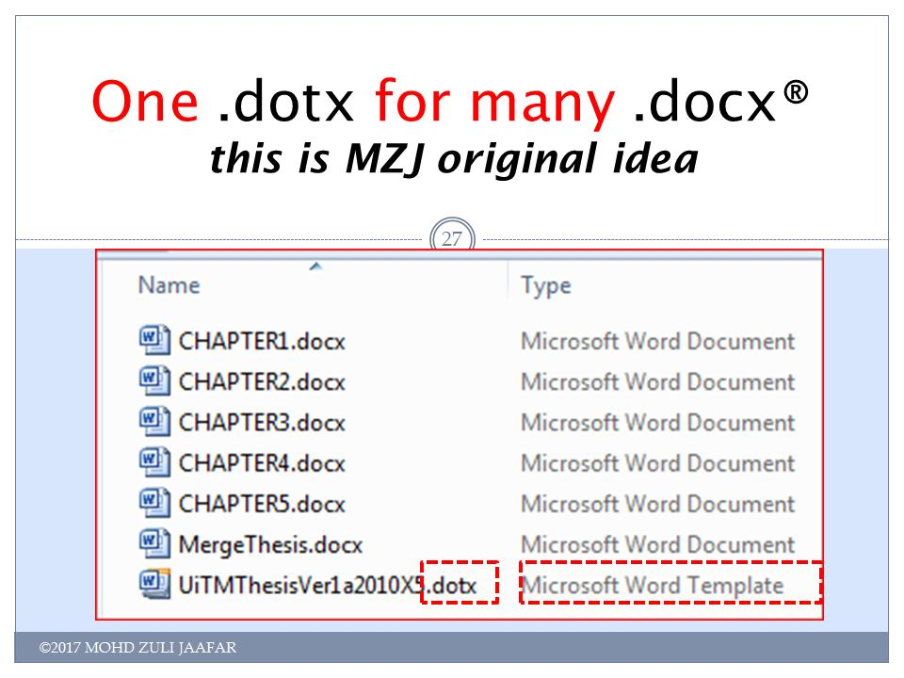
Figure 4.1 This is MZJ original idea

Analytical Proofs
- Video provides a powerful way to help you prove your point
- When you click Online Video, you can paste in the embed code for the video you want to add.
- You can also type a keyword to search online for the video that best fits your document.
- To make your document look professionally produced, Word provides header, footer, cover page, and text box designs that complement each other.
- For example, you can add a matching cover page, header, and sidebar.

Result and Discussion
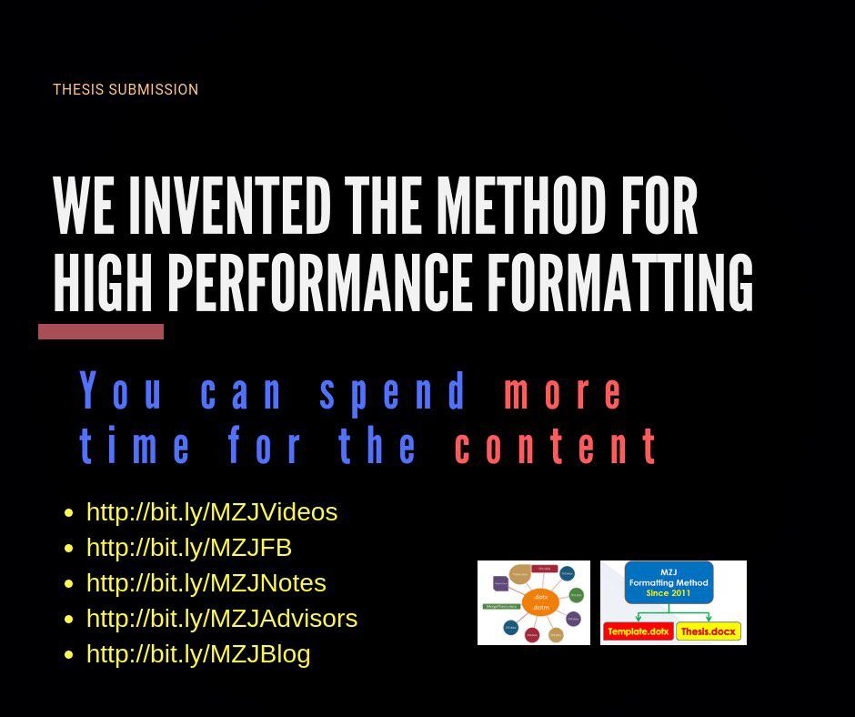
Figure 4.2 The method for hig performance formatting

Chapter Summary

Title | Title | Title | Title | Title | Title | Title
 |  |  |  | 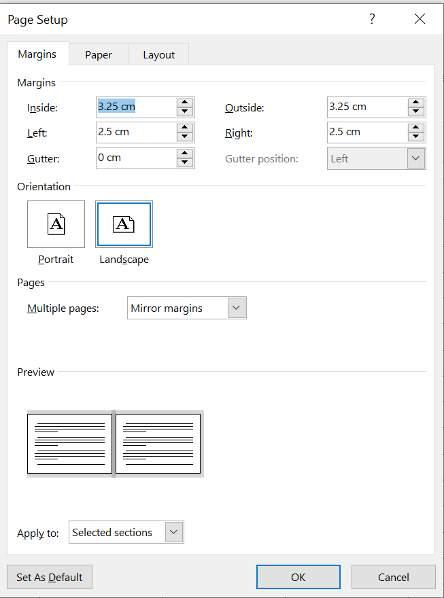

CONCLUSION AND RECOMMENDATIONS

Research Outcomes

Contributions to Knowledge
(1.1)

After deliberating on doctoral education in Australia in the 1990s, one observer I Australia writes:
The lack of any significant formal course work within our Ph.D. and master degrees by research has continued for three decades. The focus of our Ph.D. research type degrees continues to be the research project, and this is almost the only medium by which education is accomplished.
(Stranks, 1984:171)

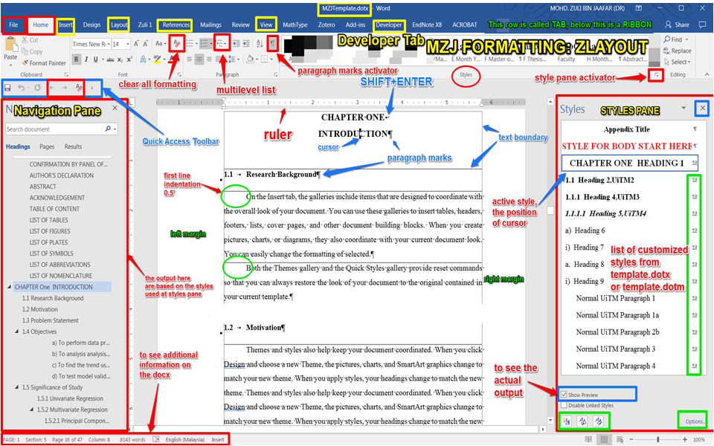
Figure 1.1 Trends leading to the problem using MZJ Formatting Method
(If the caption is written in a single line, use Caption for Figure UTM)


Figure 1.2 Design and development phases of the proposed scheme (Muhamad, 2018)
(If the caption is written more than one line, use Caption for Figure UTM 2 line)

Table 1.1 The role of statistical quality engineering tools and methodologies
(If the caption is written in a single line, use Caption for Table UTM)

Table 1.2 Basic ANN models used for control chart pattern recognition
(If the caption is written more than one line, use Caption for Table UTM 2 line)

Future Works
Video provides a powerful way to help you prove your point. When you click Online Video, you can paste in the embed code for the video you want to add. You can also type a keyword to search online for the video that best fits your document.
Table 5.1 Example Repeated Header Table
Title | Title | Title | Title
Video provides a powerful way to help you prove your point. When you click Online Video, you can paste in the embed code for the video you want to add. You can also type a keyword to search online for the video that best fits your document. To make your document look professionally produced, Word provides header, footer, cover page, and text box designs that complement each other.

REFERENCES
Chen, M.-C. and Huang, S.-H. (2003) ‘Credit scoring and rejected instances reassigning through evolutionary computation techniques’, Expert Systems with Applications, 24(4), pp. 433–441.

Appendix C Time-series Results Long Long Long Long Long Long Long Long Long Long

LIST OF PUBLICATIONS
Journal Articles
Qasem, S. N., Shamsuddin, S. M., Hashim, S. Z. M., Darus, M., & AlShammari, E. (2013). Memetic multiobjective particle swarm optimization based radial basis function network for classification problems. Information Sciences, 239, 165–190. https://doi.org/10.1016/j.ins.2013.03.021. (Q1, IF: 4.305)
Qasem, S. N., & Shamsuddin, S. M. (2011). Radial basis function network based on time variant multi-objective particle swarm optimization for medical diseases diagnosis. Applied Soft Computing, 11(1), 1427–1438. https://doi.org/10.1016/j.asoc.2010.04.014. (Q1, IF:3.907)
Shen, L. W., Asmuni, H., & Weng, F. C. (2015). A modified migrating bird optimization for university course timetabling problem. Jurnal Teknologi, 72(1), 89–96. https://doi.org/10.11113/jt.v72.2949. (Indexed by SCOPUS)

Conference Proceedings
Muhamad, W. Z. A. W., Jamaludin, K. R., Ramlie, F., Harudin, N., & Jaafar, N. N. (2017). Criteria selection for MBA programme based on the mahalanobis Taguchi system and the Kanri Distance Calculator. In 2017 IEEE 15th Student Conference on Research and Development (SCOReD) (pp. 220–223). IEEE. https://doi.org/10.1109/SCORED.2017.8305390. (Indexed by SCOPUS).

Mary Duncan Carterand Rose Mary Magrill, “Building Library Collections" Fourth edition. (Metuchen, N. J.: Scarecrow Press, 1974), pp.61 - 66.

